

**Bare metal Installation**

**ESBPII**

IT 13 0673 66

CKB Wickramasinghe

Weekend

Github link :-

https://github.com/KanishkaPicaros/ESBPII-BareMetal-Installation/blob/master/BareMetalInstallation.docx

**Lab4**

Introduction

In order to have a full utilization of your machine resources we can use a bare metal installation. By using only one operating System to run on machine the machine recourse are been underutilized.

By doing a bare metal installation we can create several concurrently running isolated virtual machines. Which will also utilize all the machine resources efficiently.

**Doing a Bare metal Installation**

We will be installing the esxsi software in order to run the software.This is called a hypervisor. The hypervisor will be enabling to install multiple operating systems on same harware. The Operating system and the hardaware has no bond in between.There for there is no limitations to install multiple operating systems. It directly enables operating systems to interact with the physical machines hardware.

There are two types of hypervisors

* Bare metal Hypervisor
* Hosted Hypervisor

By using a hypervisor virtualization is been done.

Virtualization will be providing

* Server consolidation
* Isolation
* Encapsulation
* Hardware independence
* Reduced Cost

In order to do bare metal installation we must first have a machine has no operating systems and must be installed with ESXI on the hardware

Creating a machine (Virtual machine with the computer’s features).

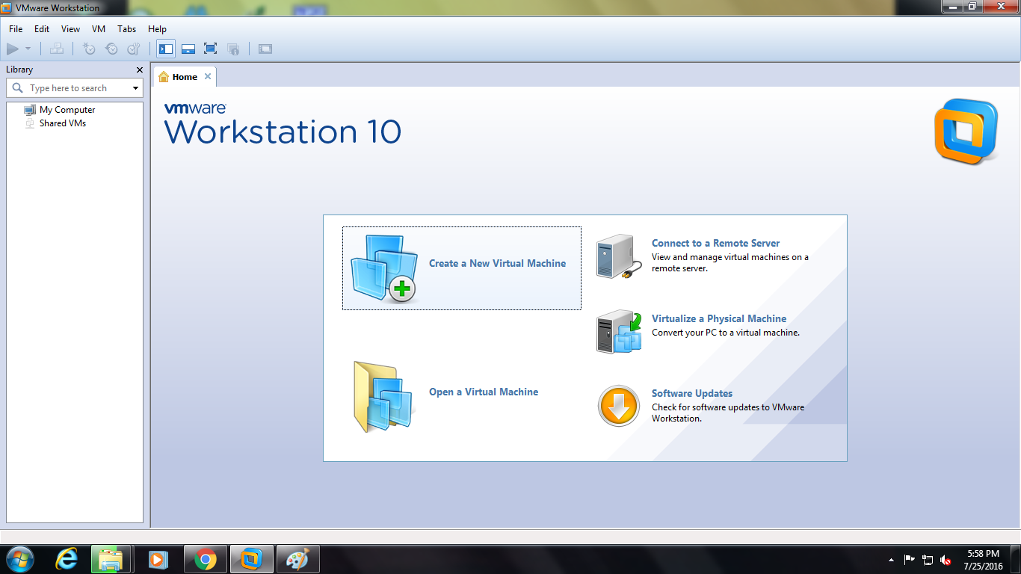

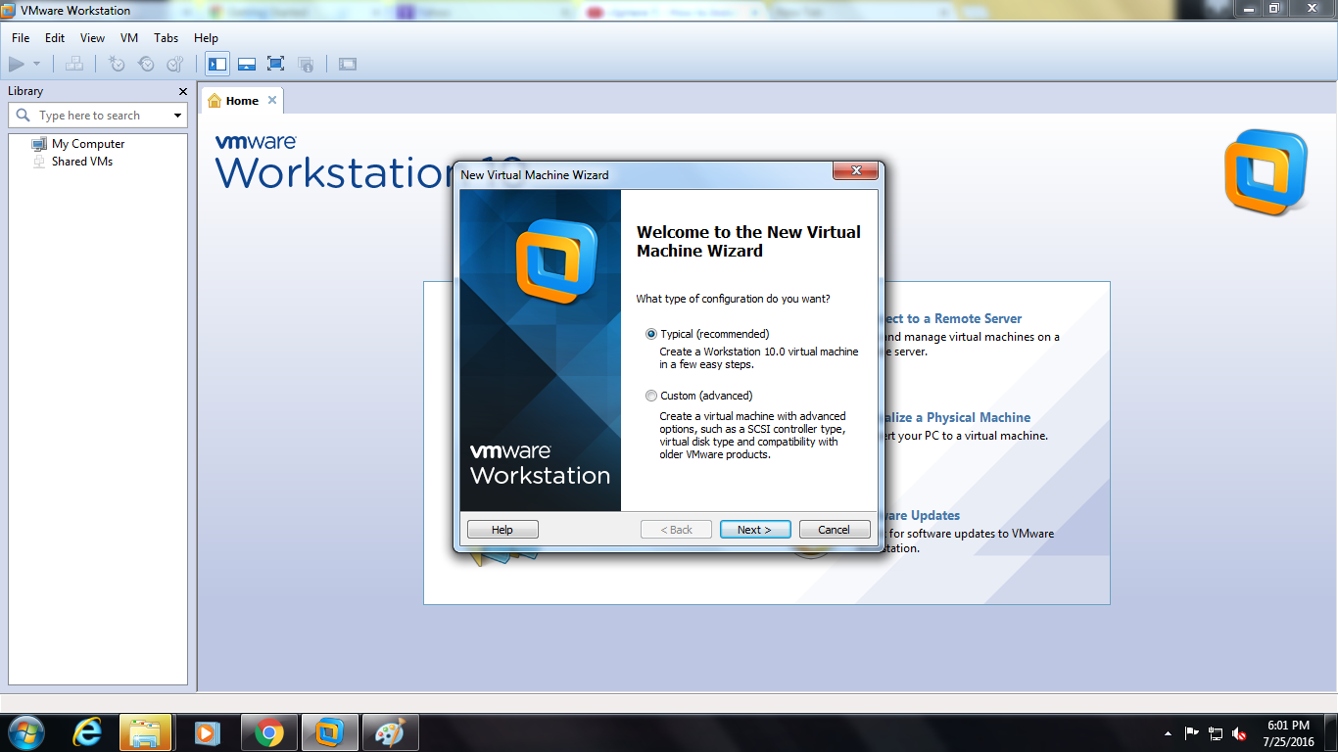

Install ESXI on machine without Operating system.Select ISO of ESXI and click next

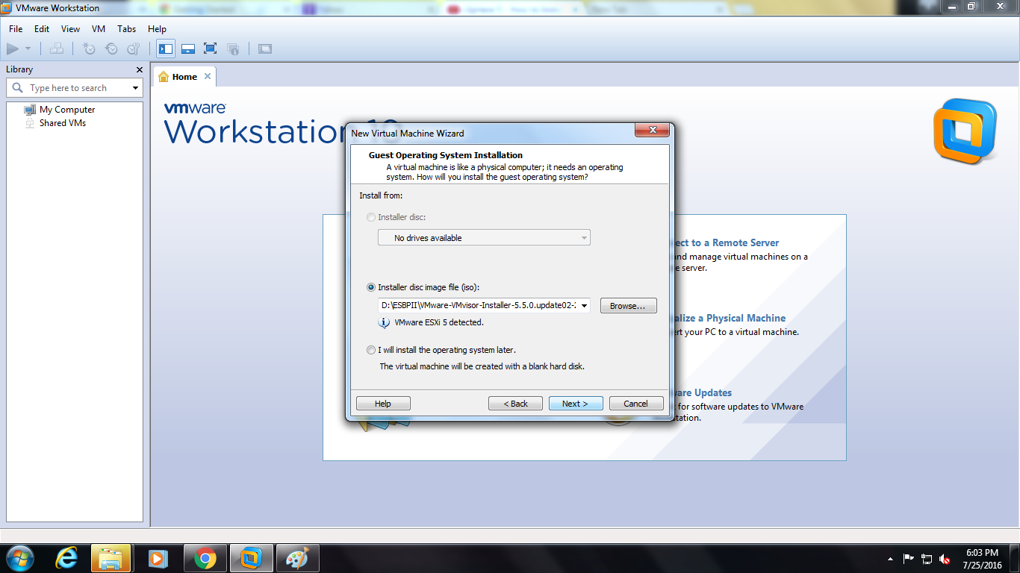

Creating machine with ESXI. Select store virtual disk as single file and provide a virtual hard disk of 40GB

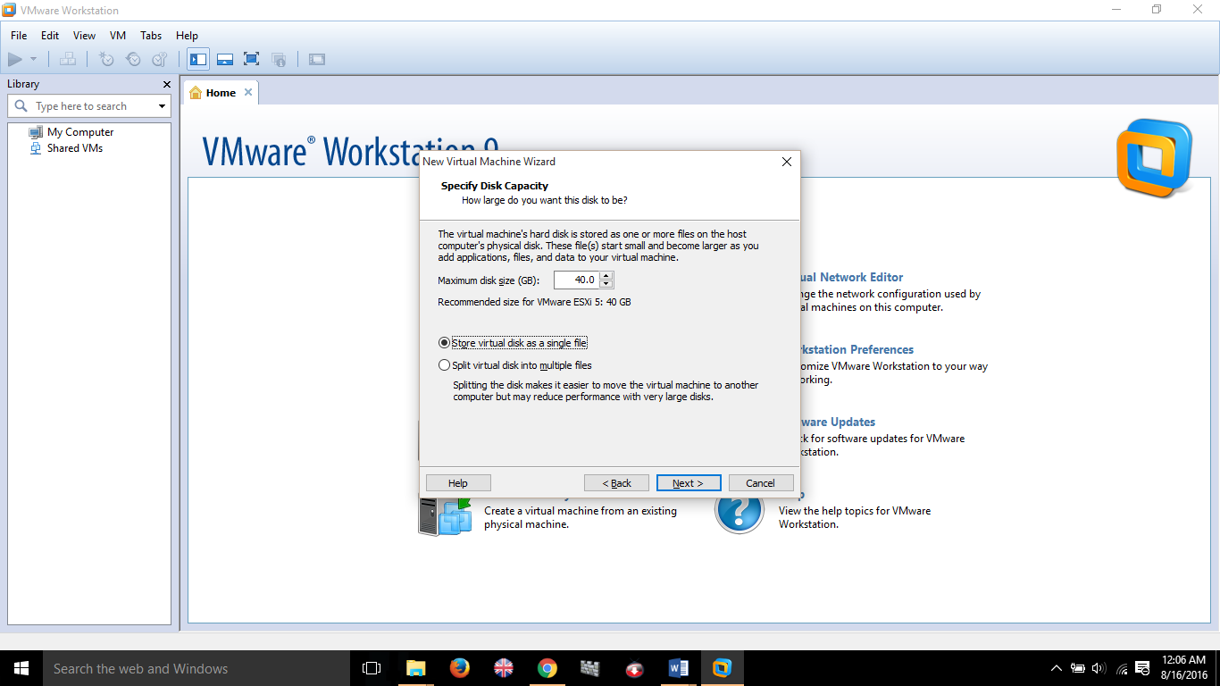

Confirm or edit tha virual machine resours. Then click Finish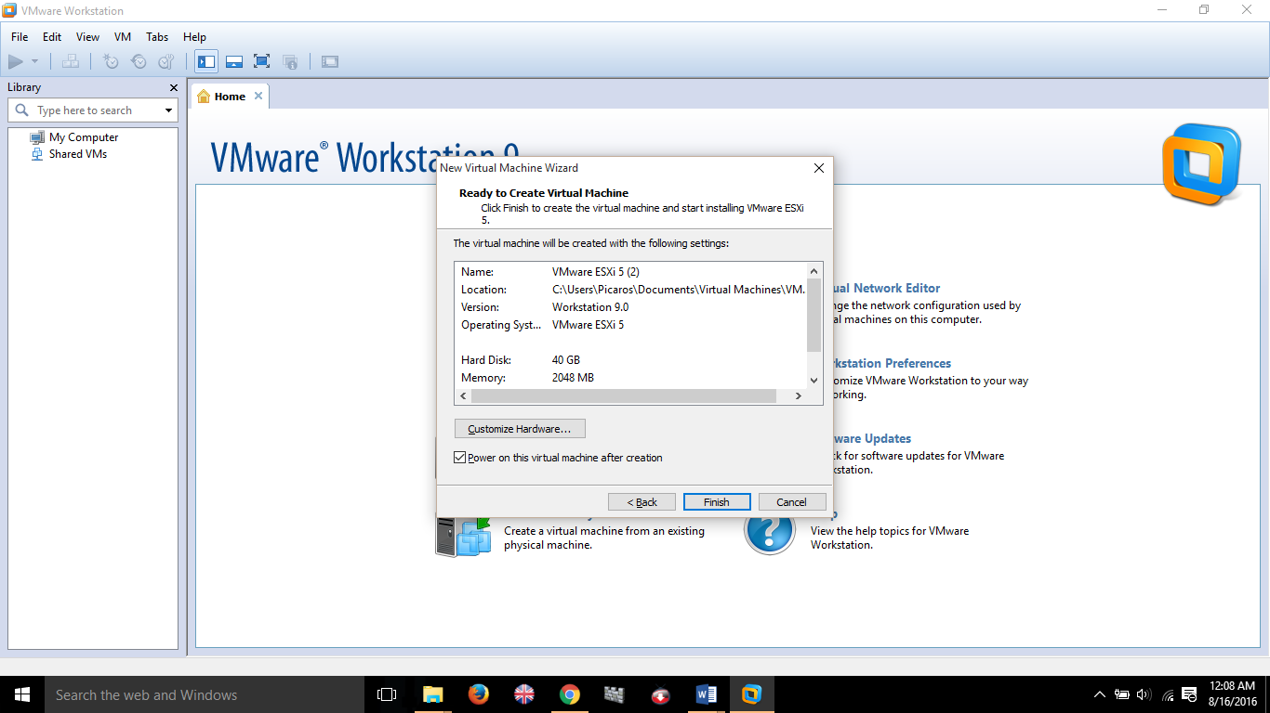

Installing ESXI (Hypervisor)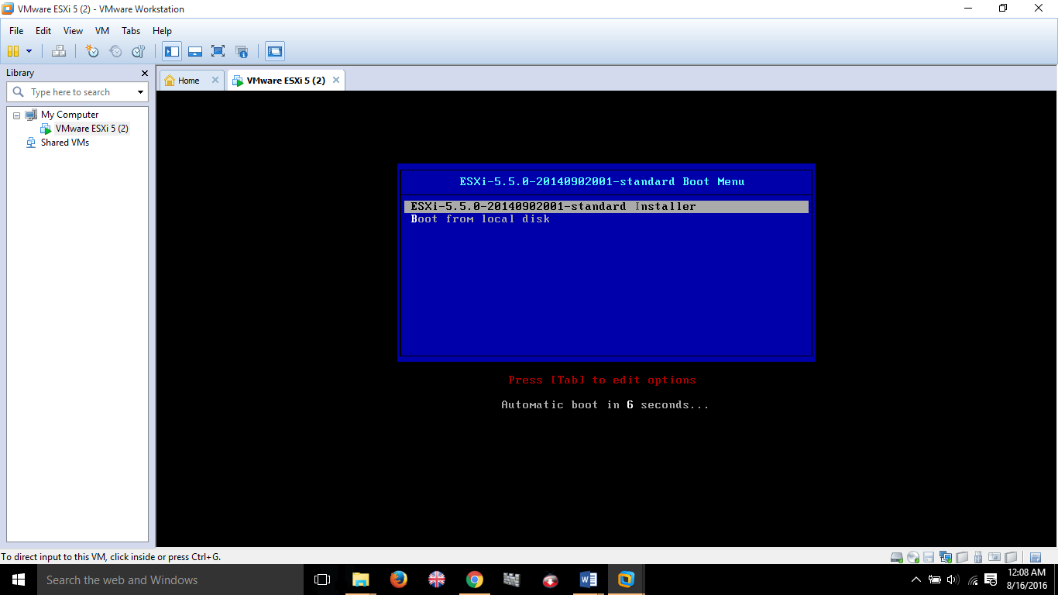

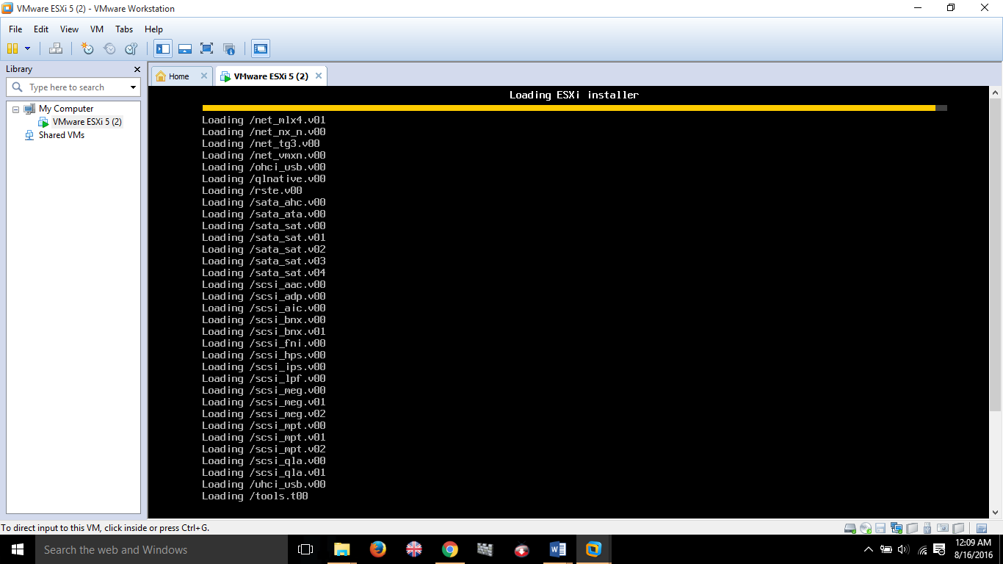

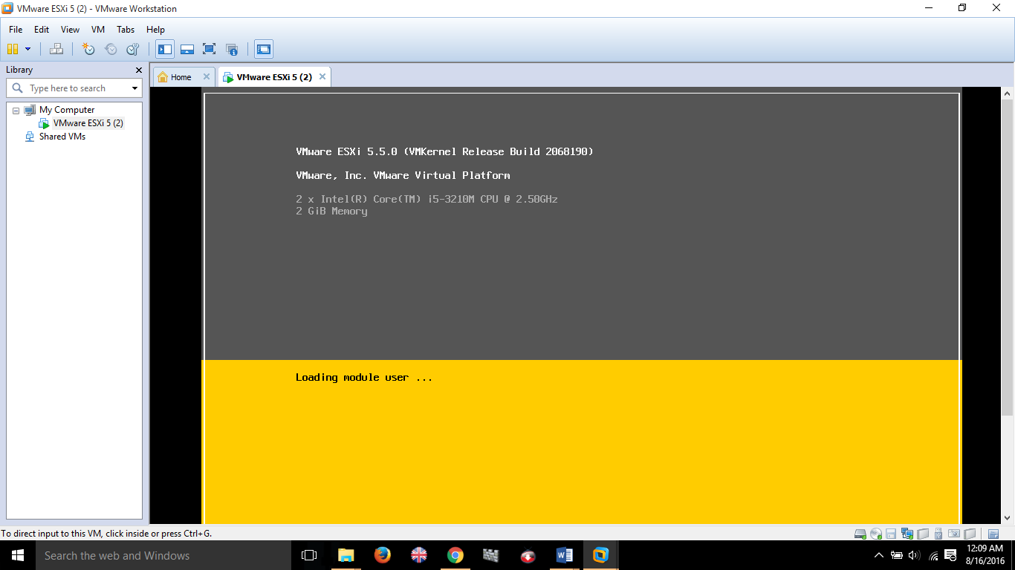

Installing ESXI 5.5.0 to machine

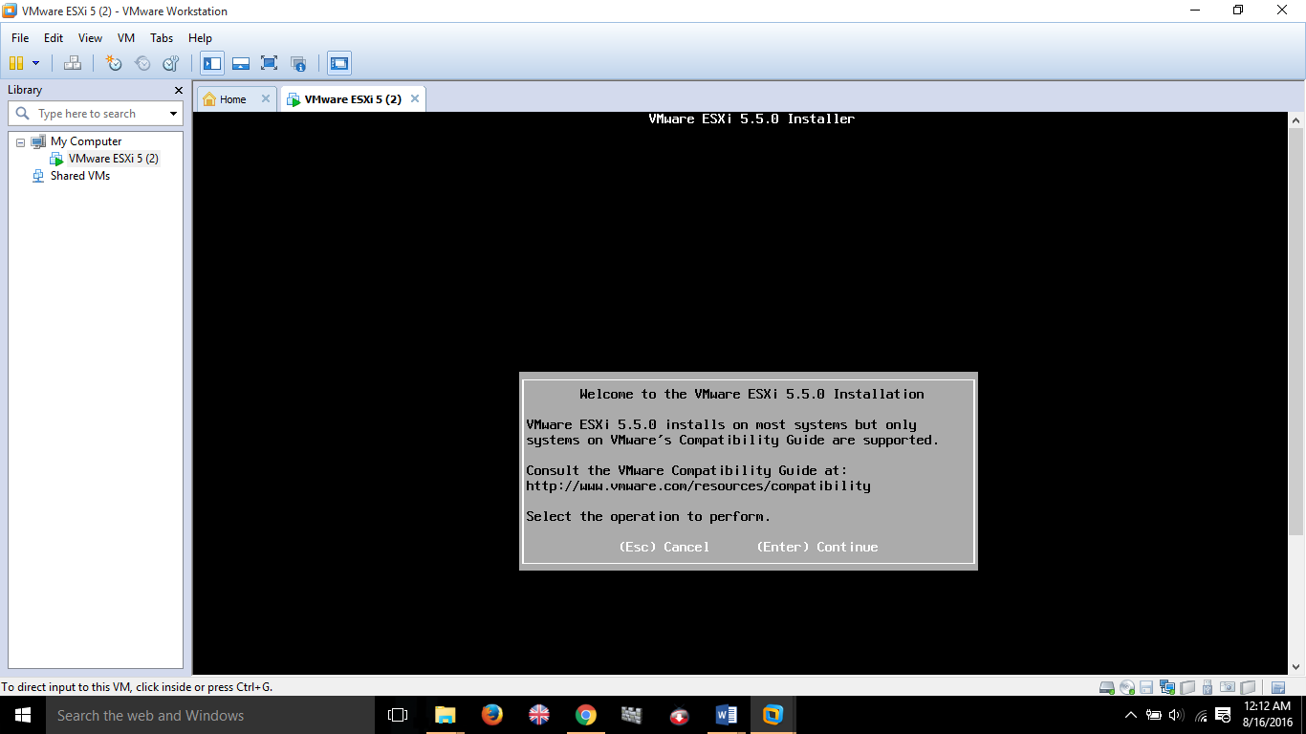

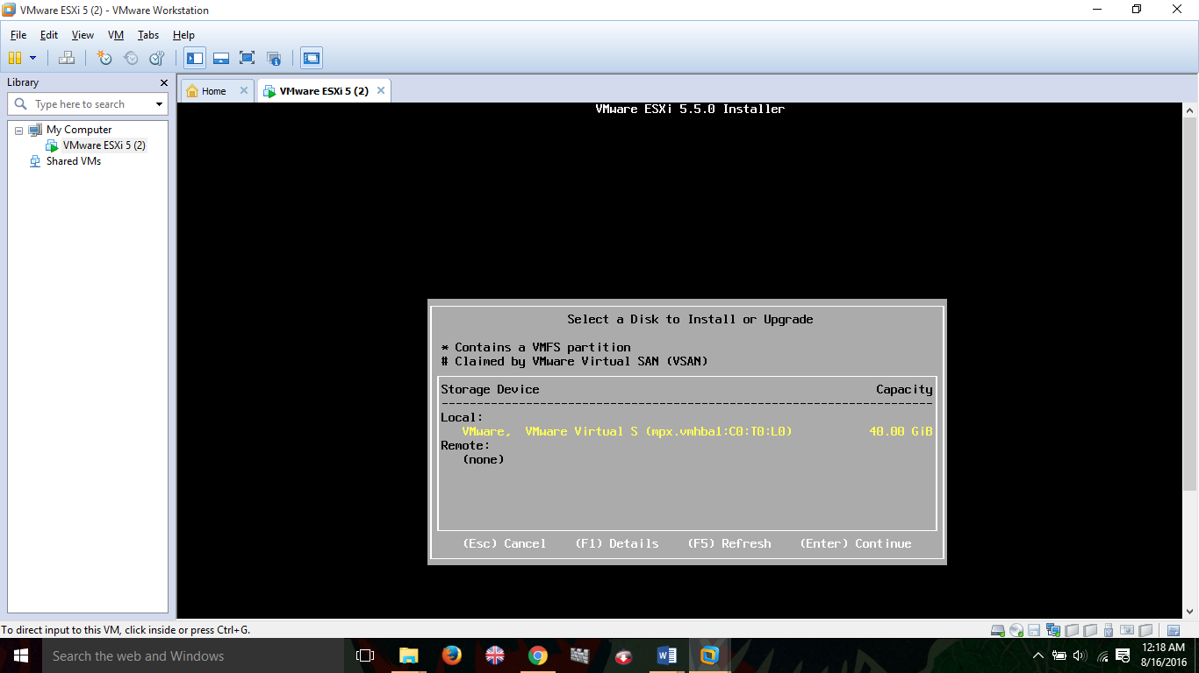

Select oparating language..

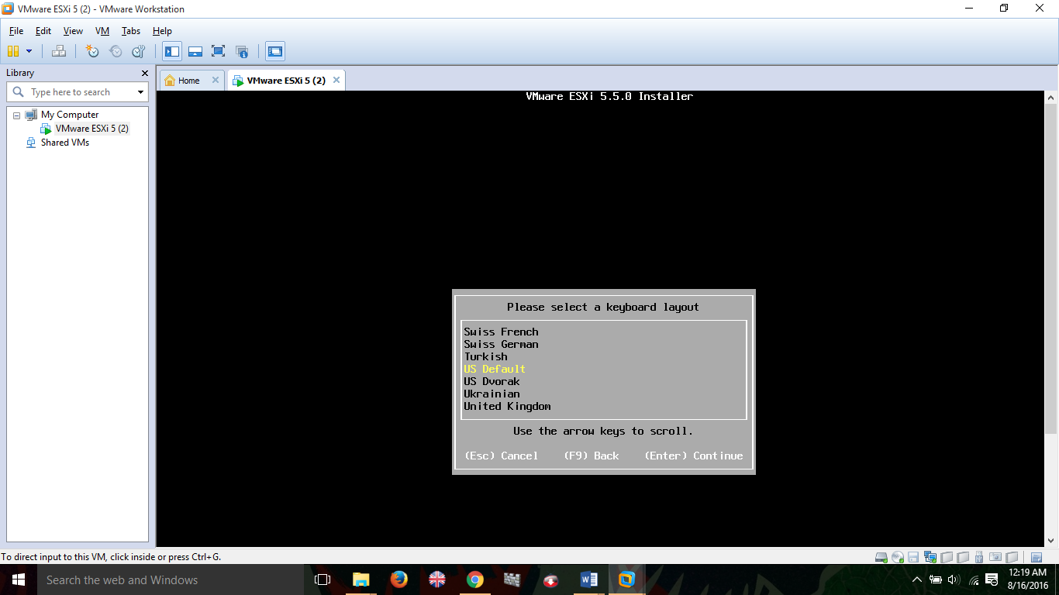

Set root pasword and confirm the password

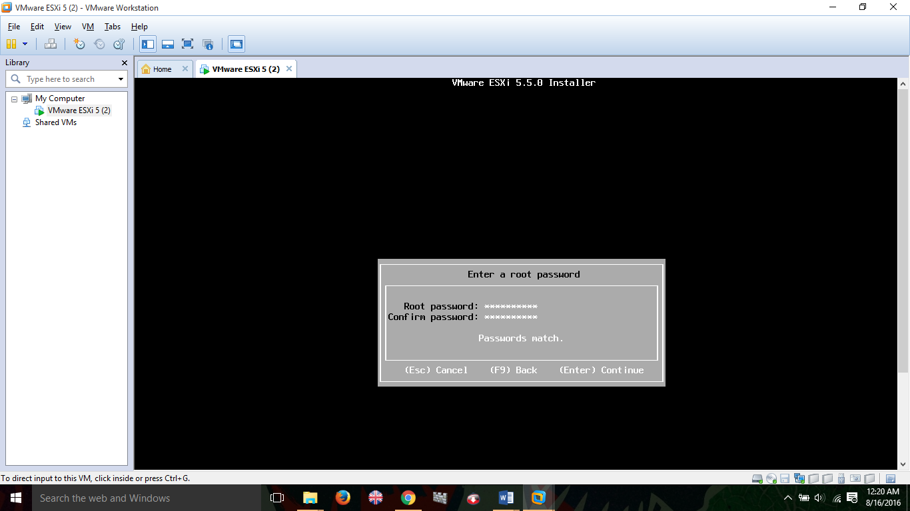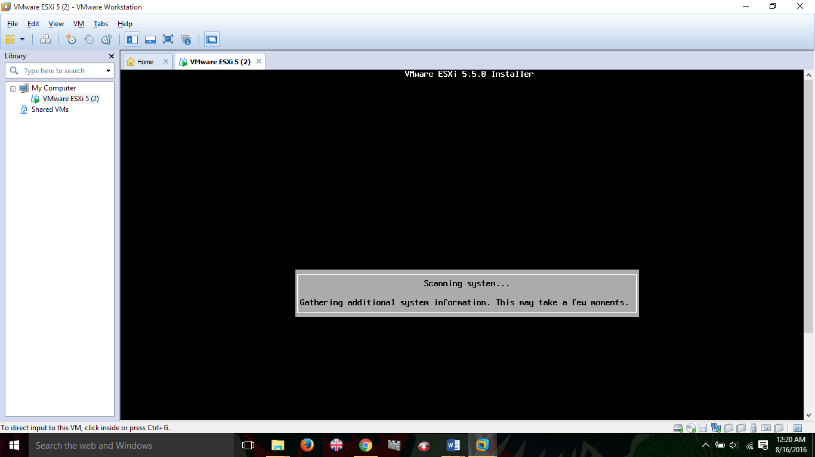

After installing esxi succuessfully to the machine must obtain the IP address.

Then Run VM Weare vshre client Enter IP address and user name and password.

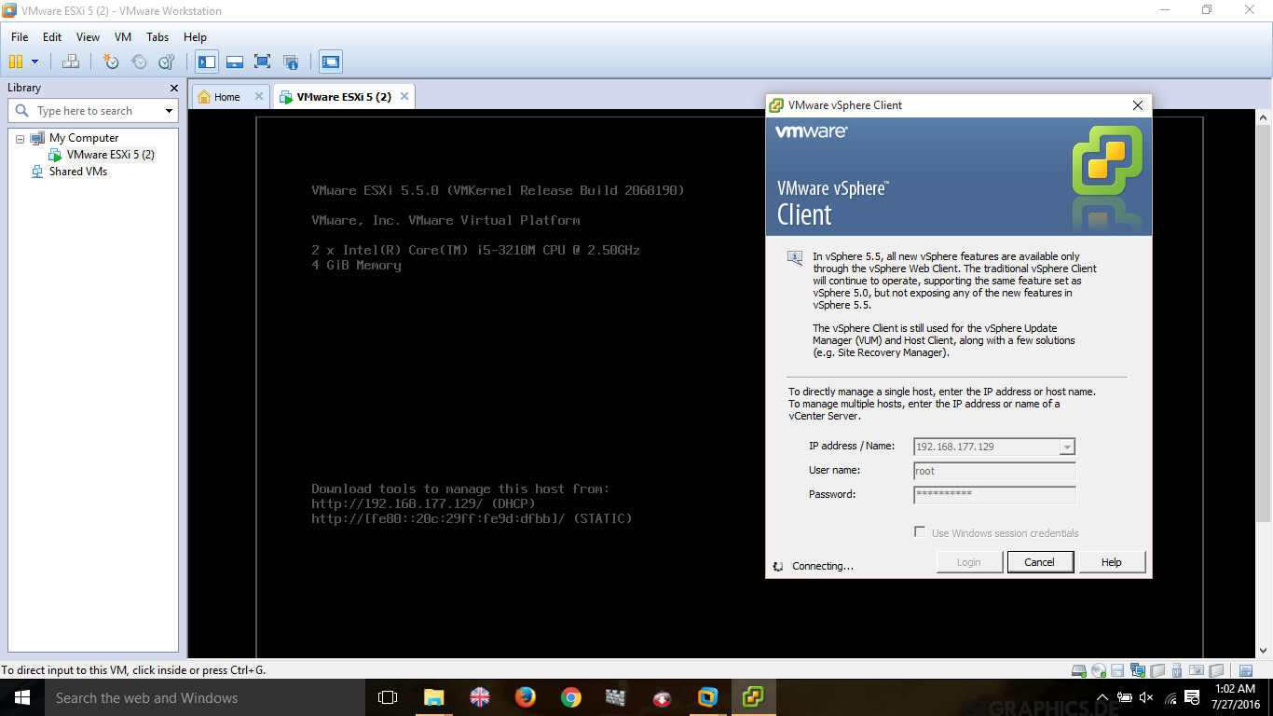

Click on inventory.

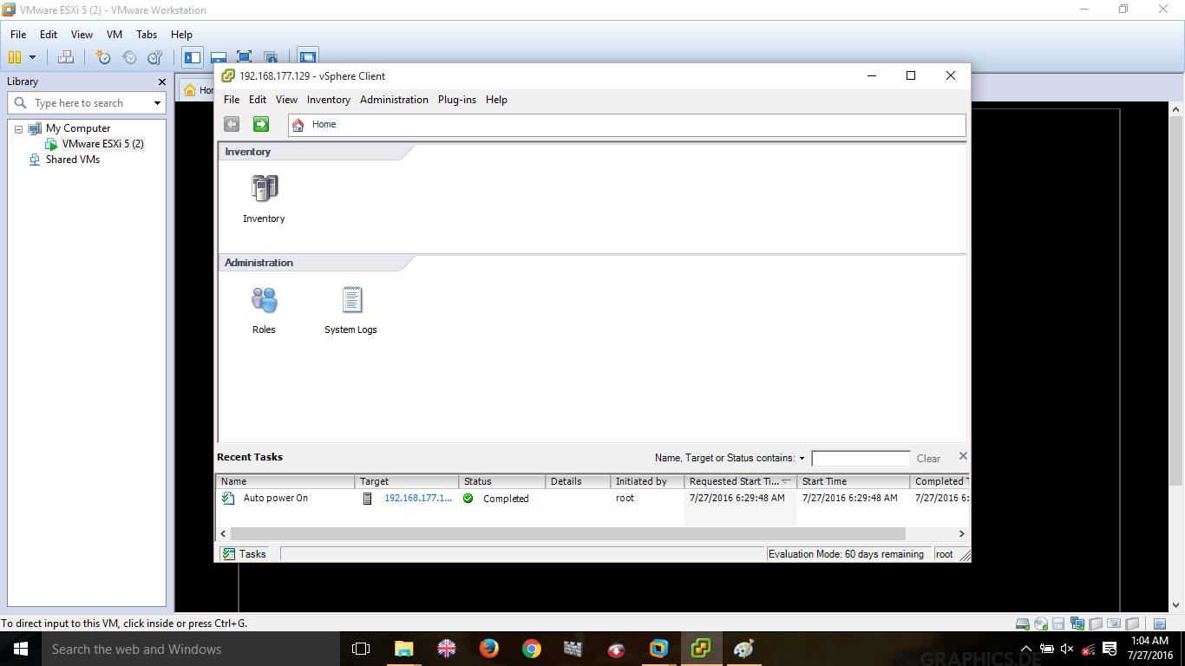

Open inventory

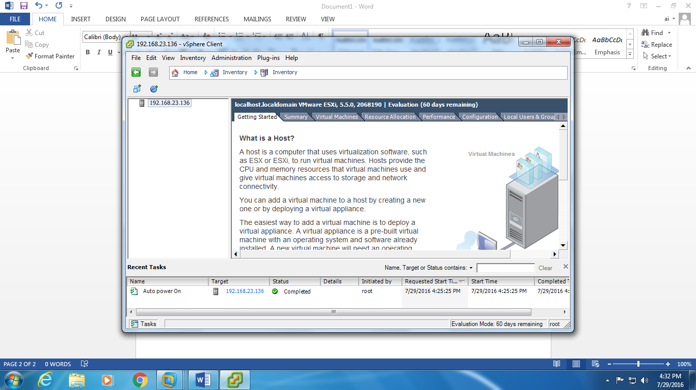

Go to summery tab click on data store.

Open data store in VM VSphere client. And set Operating system and upload it.

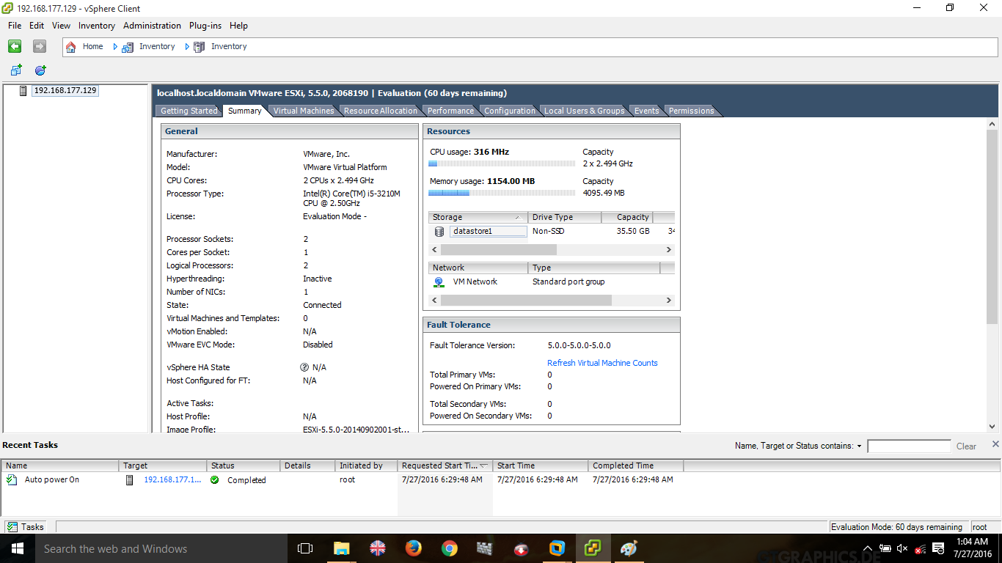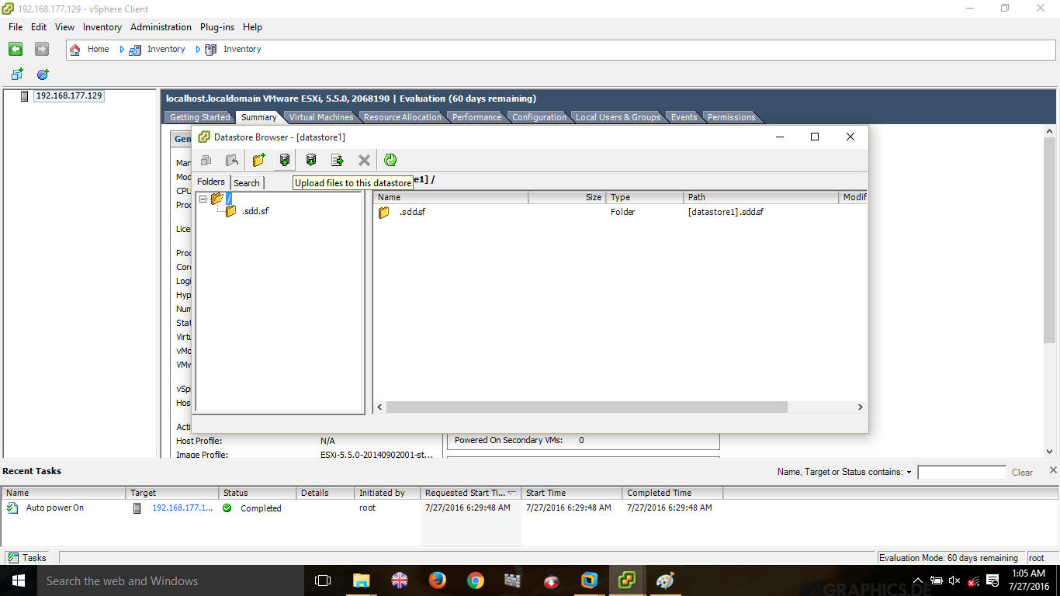

Uploading Operating system.

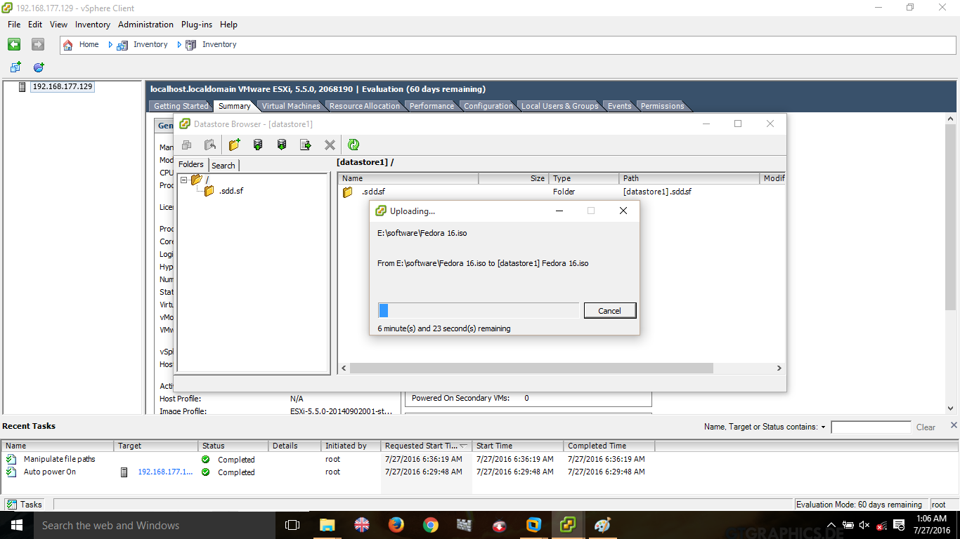

Successfully upload operating system to data store.

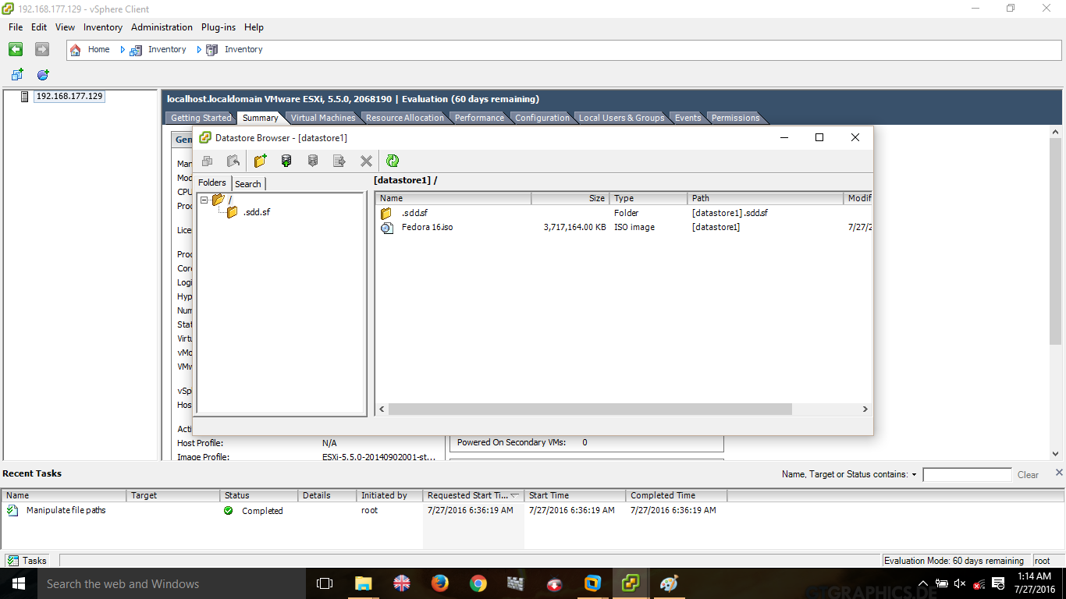

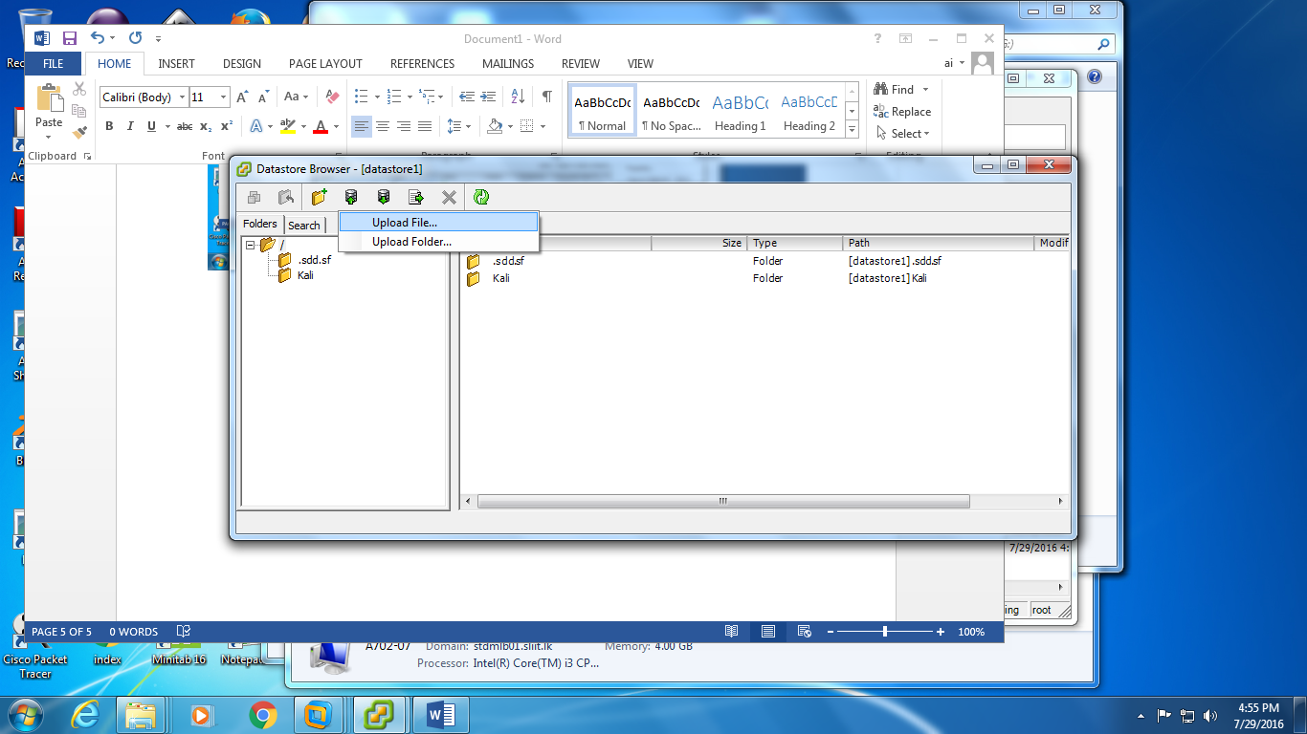

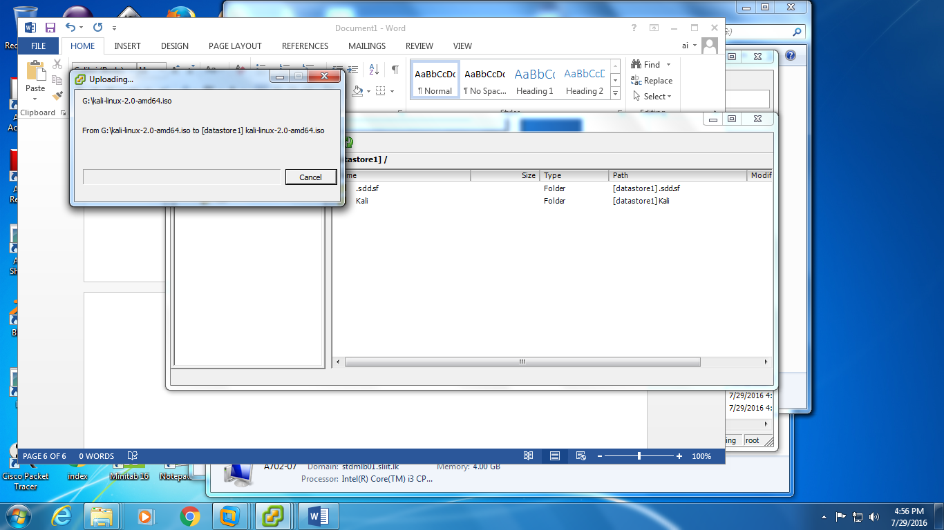

Create new virtual machine in vm-vsphere.

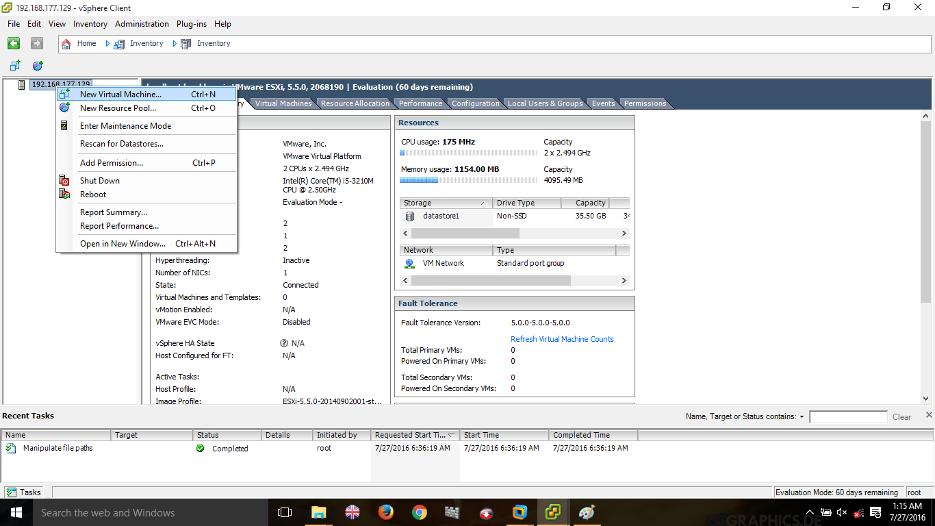

Select option typical in creating virtual machine.

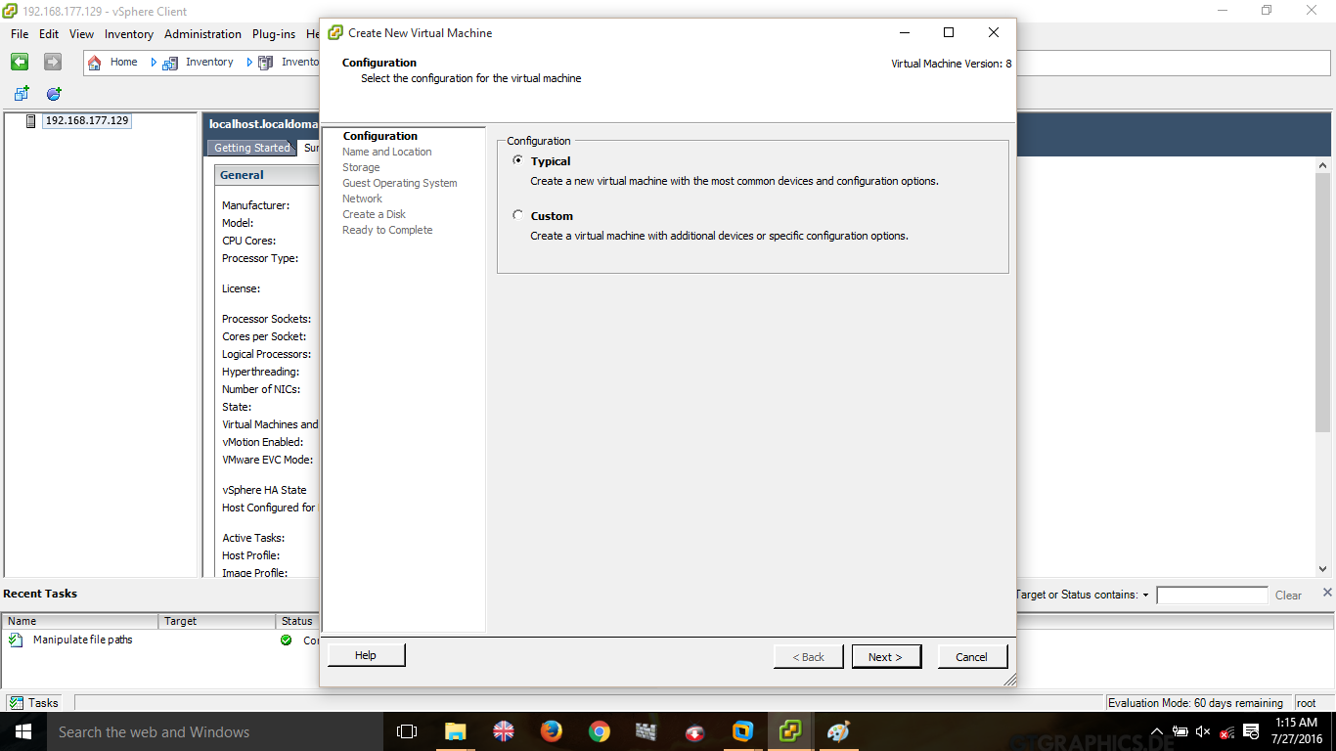

Name the virual machine that we hope to create

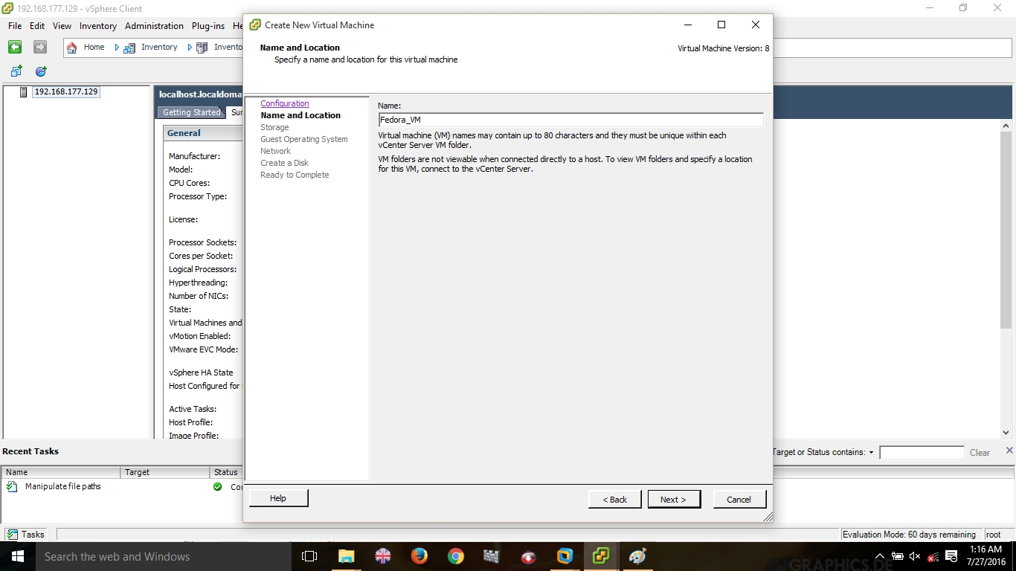

Create a new virtual machine and go to data store

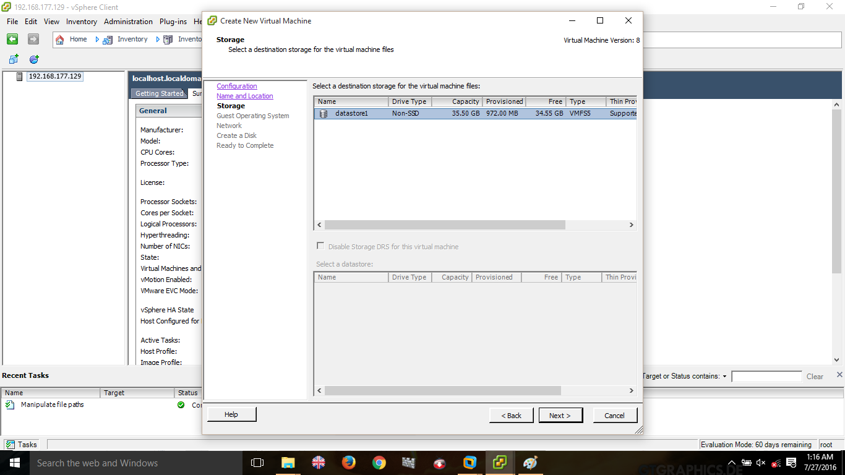

Select the oparating system type.

First select the oparating system type and then select the oparating system version (Eg: for Kali linux you can use Debium 5) Then Click next.

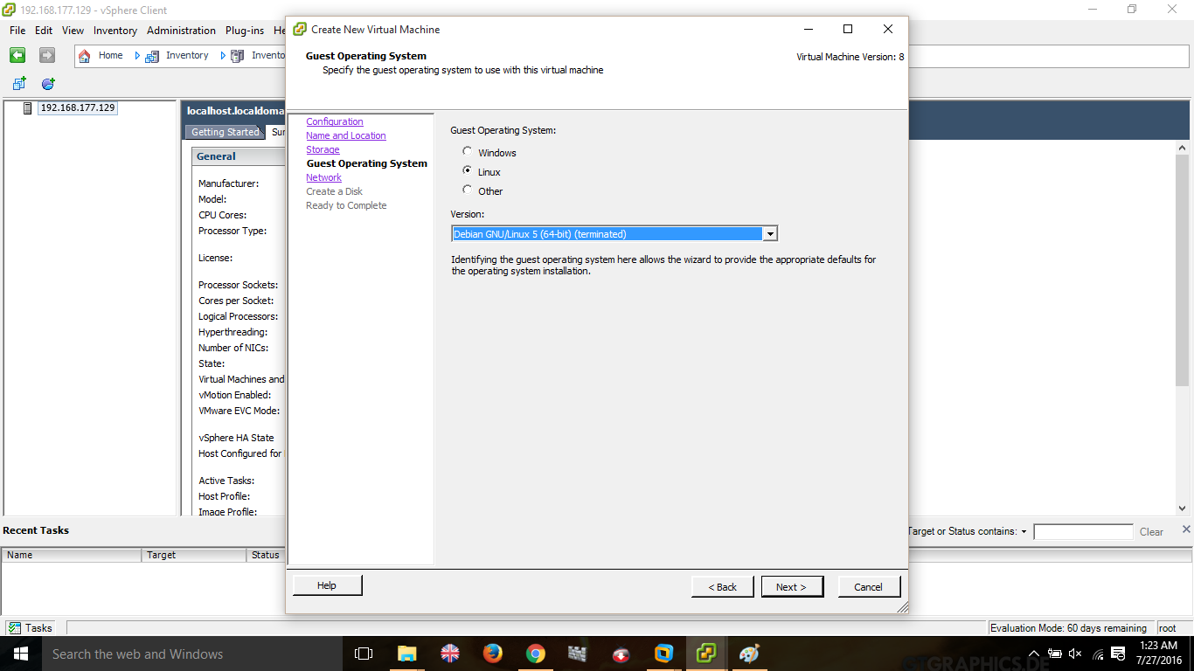

Give the default oparating system’s network settings.

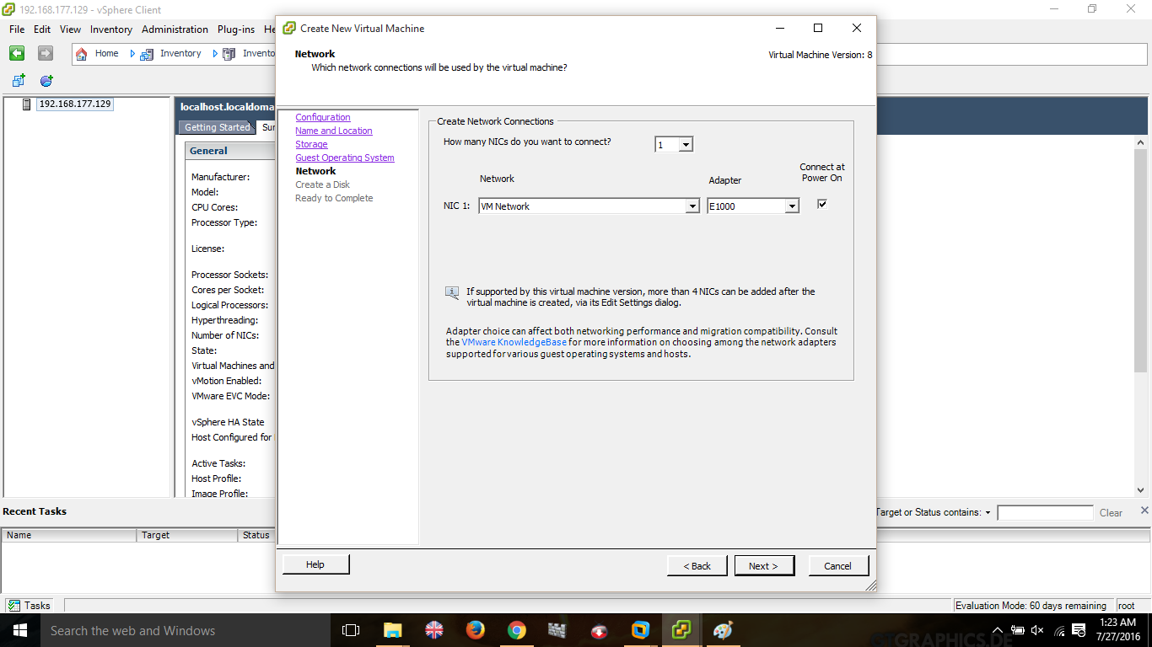

Select “Thin provision” befor creating/ When creating virtual machine and click next

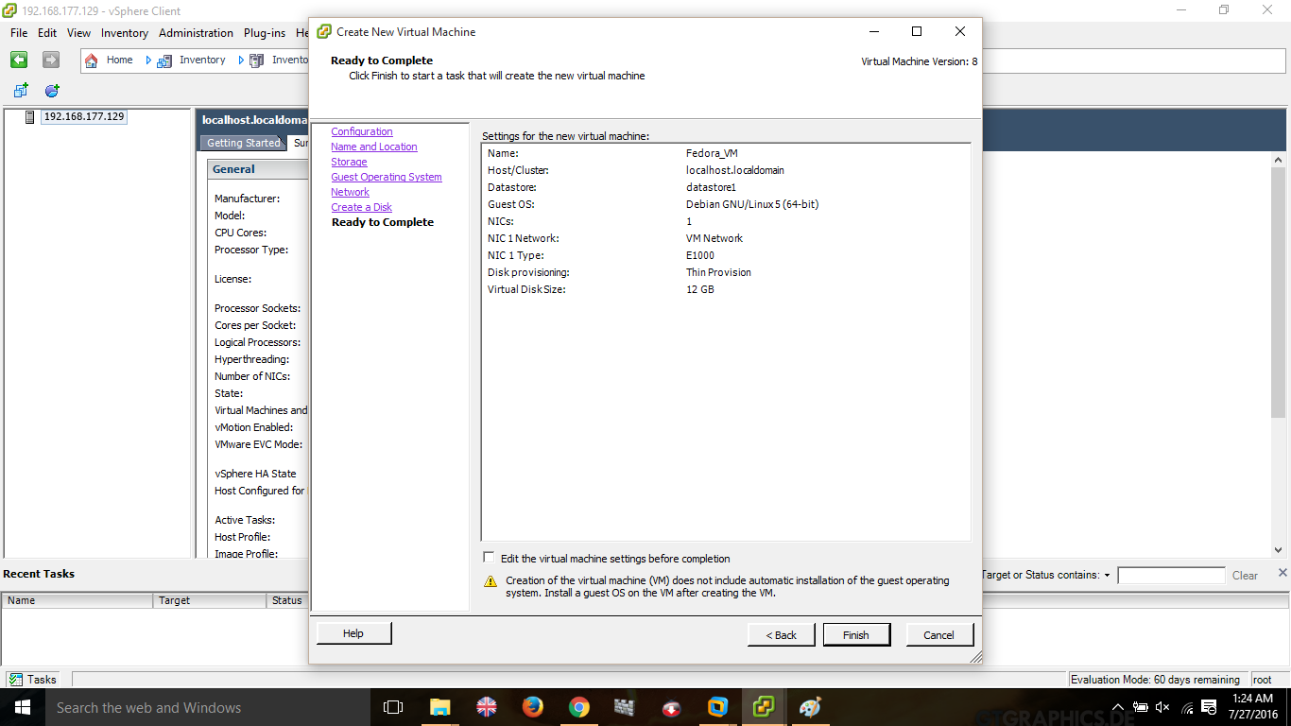

In the final step click on finish

Power on the created vsphere client machine.

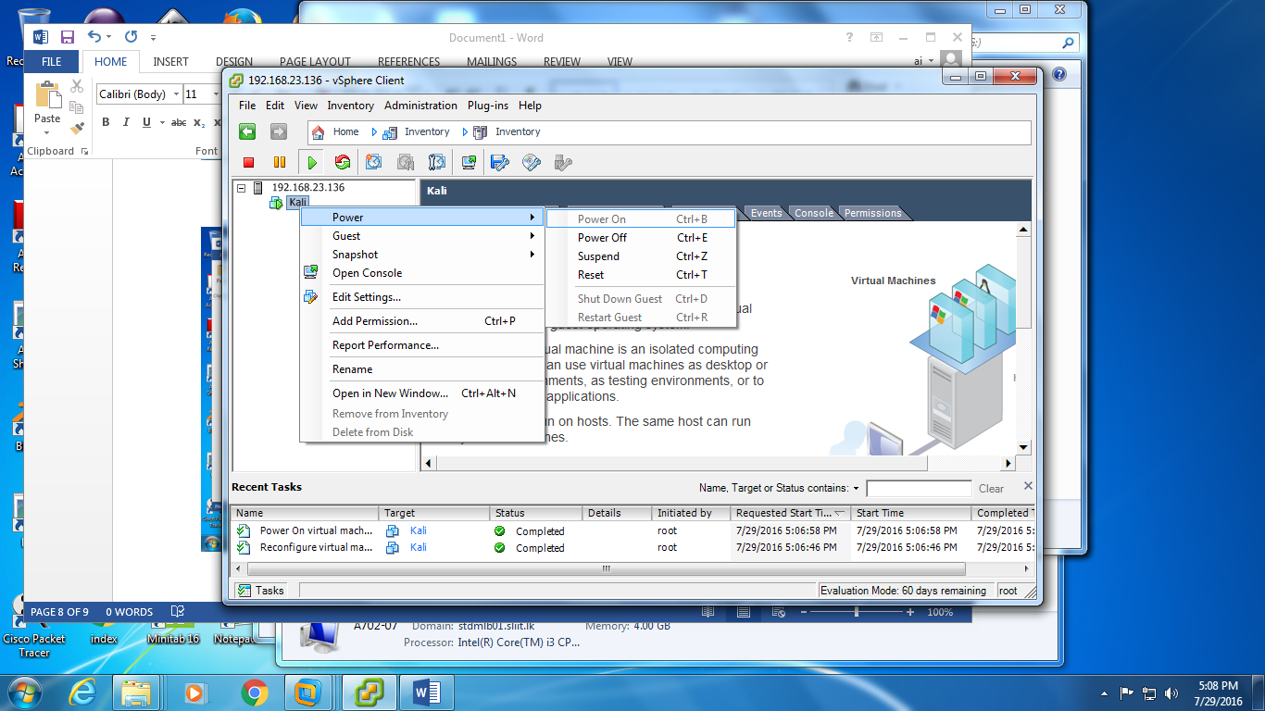

Install the uploaded operating system which is in the data store.

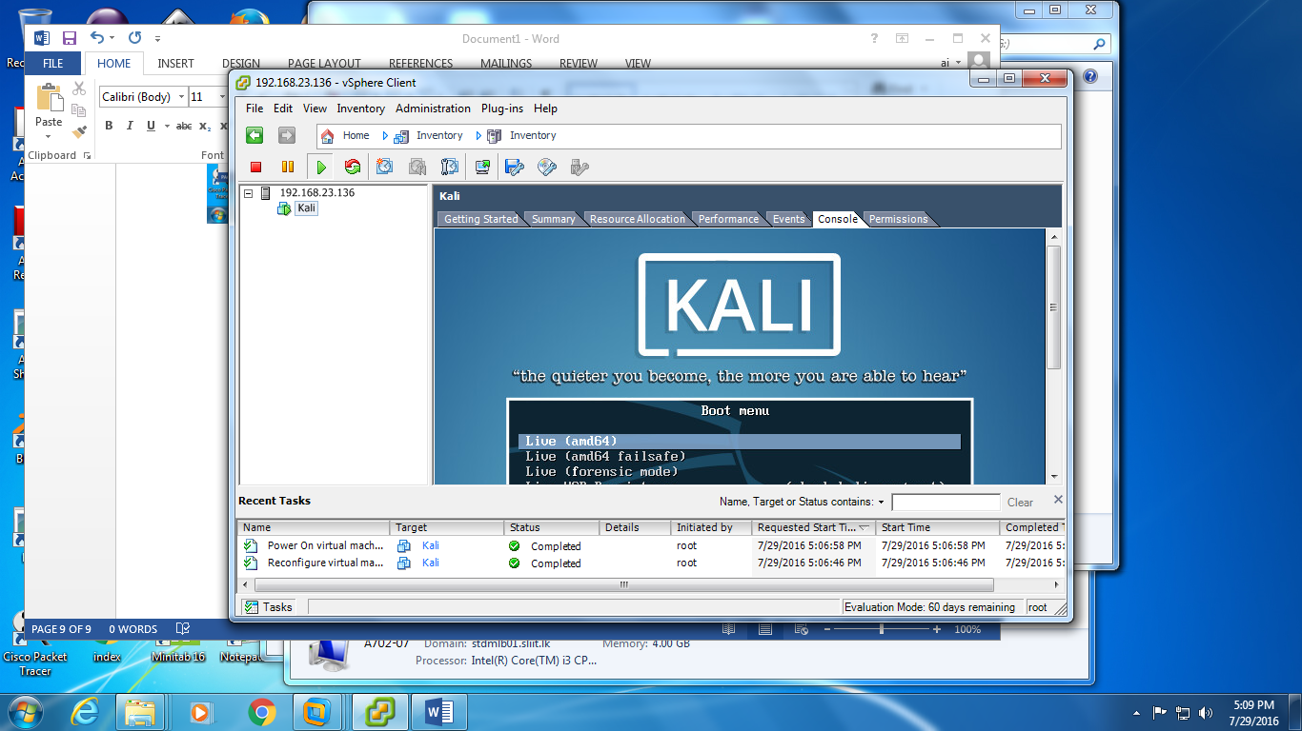

Follow the normal installation procedure. To complete the operating system insrtallation

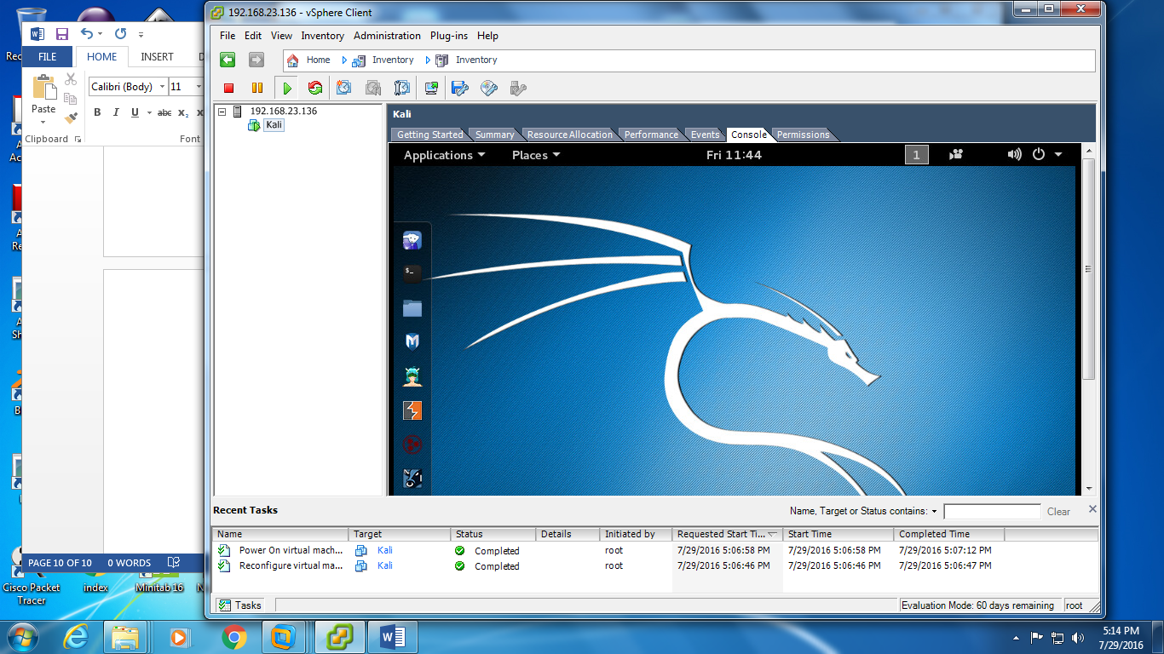

In the installation kali linux is been used.